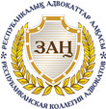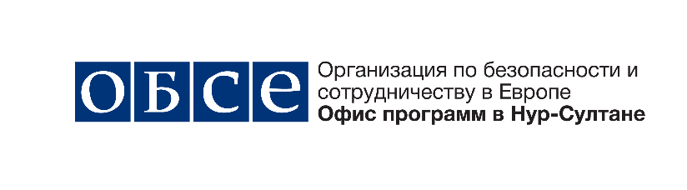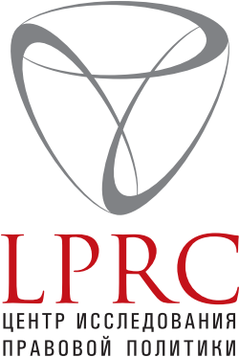

IV FORUM OF KAZAKHSTAN DEFENSE LAWYERS

RIGHT TO LEGAL ASSISTANCE AND ADVERSARIAL PROCEDURE: EFFECTIVE IMPLEMENTATION
IN KAZAKHSTAN

November 15, 2019
Nur-Sultan

Program

09.00 – 09.30 | Registration
09.30 – 10.00 | Opening  Greetings  Kadyrzhan BAYMUKHANOVA, Chairman of the Republican Bar of Lawyers  Diana DIGOL, Deputy Head of the Programme Office in Nur-Sultan  Tatyana ZINOVICH, Head of “Legal Policy Research Center”
PANEL DISCUSSION I. COMPETITION AND EQUALITY OF THE PARTIES IN THE CRIMINAL PROCESS: ILLUSION OR REALITY?

MODERATOR: Aidyn BIKEBAYEV, member of the Presidium of the Almaty City Bar, Chairman of the Qualification Commission at the Supreme Judicial Council, Managing Partner of “Sayat Zholshy & Partners” Law Firm
10.00 – 10.30 | The initiators of the discussion:  “Actual issues of the adversarial and equal rights of the parties in criminal proceedings”, Gulnara MERGENOVA, Judge of the Supreme Court of the Republic of Kazakhstan  “The effectiveness of professional protection in modern realities”, Daniyar KANAFIN, lawyer of the Almaty City Bar, chairman of the Disciplinary Commission of the Republican Bar  “Further Improvement of the Code of Criminal Procedure of the Republic of Kazakhstan on the issues of the right to defense”, Salimzhan MUSIN, member of the Presidium of the Almaty City Bar
10.30 – 11.30 | Discussion
11.30 – 12.00 | Coffee-break
SESSION II. INFLUENCE OF NEW CRIMINAL PROCEDURAL INSTITUTIONS ON PROTECTION EFFICIENCY AND QUALIFIED LEGAL AID

MODERATOR: Tatyana ZINOVICH, Acting director of the “Legal Policy Research Center”
12.00 – 12.30 | The initiators of the discussion:  “The relevance and fundamental possibility of introducing the Estonian practice of filing an act of defense into a court in Kazakhstan’s criminal procedure”, Yerlan MUKASH, lawyer of the Akmola regional bar  “Jury trial as an incentive for the development of legal profession”, Murat ZHANBAEV, Member of the Almaty City Bar, Member of the Scientific Advisory Council at the Republican Bar  “The system of appointing lawyers as advocates in  criminal proceedings: the experience of Russian lawyers. Epxperience of Russian Federation”, Sergey GAVRILOV, Advisor to the President on Information Technologies, Federal Chamber of Lawyers of the Russian Federation  “Actual international legal aspects of the system of information support for lawyers by the example of the Republic of Kazakhstan”, Almas DEMESINOV, Member of the Almaty Regional Bar
12.30 – 13.30 | Discussion
13.30 – 14.30 | Lunch
SESSION III. RIGHT TO PROTECTION AND LEGAL PRACTICE

MODERATOR: Daniyar KANAFIN Kairatovich, lawyer of the Almaty City Bar, chairman of the Disciplinary Commission of the Republican Bar
14.30 – 15.00 | The initiators of the discussion:  “Suggestions for improving the regulation of activities of lawyers in order to increase the status of the legal profession”, Aidyn BIKEBAEV, member of the Presidium of the Almaty City Bar, Chairman of the Qualification Commission at the Higher Judicial Council, Managing Partner of “Sayat Zholshy & Partners” Law Firm  “Guarantees of advocacy. Problems and solutions ”, Asel TOKAEVA, member of the Presidium of the Republican Bar, lawyer at the Bar of the city of Nur-Sultan  “Actual issues of protecting the rights of lawyers”, Amanzhol MUKHAMEDYAROV, lawyer of the Bar of the city of Nur-Sultan, chairman of the Commission for the Protection of Lawyers
15.00 – 16.00 | Discussion
16.00 – 16.30 | Official closing of the Forum
16.30 – 17.30 | Coffee

