PRESS RELEASE

27 May 2021

A round table on the influence of various actors on migration processes
in the Republic of Kazakhstan was held

On May 27, 2021, within the framework of the European Union project, a round table was held on the topic "The influence of various actors on migration processes in the Republic of Kazakhstan". The event was organized to discuss the activities of various actors which are in one way or another involved in the implementation of the rights and freedoms of migrants in Kazakhstan. A range of problems faced by migrants in the context of the ongoing COVID-19 pandemic were also taken into consideration.

State bodies authorized to regulate migration policy, lawyers, advocates, public figures, and representatives of the non-governmental sector were invited to the event.

The participants discussed various issues concerning the situation of migrants in the Republic of Kazakhstan, including the difficulties of employment and taxation of migrants, documentation and activities of non-governmental organizations, access of migrants to justice and the means of protection from collective expulsions, as well as access of migrants to medical and educational services.

The event was organized by the Legal Policy Research Center (LPRC) in cooperation with the International Commission of Jurists (ICJ) and the International Commission of Jurists - European Institutions (ICJ-EI), with financial support from the European Union under the project “Strengthening Legal Protection of Migrants' Rights in Kazakhstan”. The project aims to improve the access of migrants to national and international instruments for the protection of human rights in Kazakhstan, as well as to stimulate professional training and cooperation between specialized lawyers from Kazakhstan and their European counterparts.

For more information please contact Olga Miroshnichenko, Project Coordinator of Legal Policy Research Center: Tel.: +7 727 356 03 86, +7 701 744 44 29, e-mail: omiroshnichenko@lprc.kz or Amriyeva Yerkezhan, Political, Press and Information section, Delegation of the European Union to Kazakhstan:Yerkezhan.amriyeva@eeas.europa.eu.

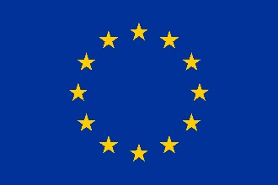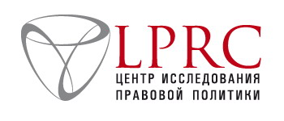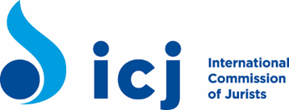

Project “Enhancing legal protection of migrants rights in Kazakhstan” is implemented by Legal Policy Reseach Center (LPRC)
Office 101, 90 Shevchenko str.
A05K7T5, Almaty, Republic of Kazakhstan
Tel.: (727) 356 03 86
info@lprc.kz
and International Commission of Jurists
This project is funded by the European Union
Delegation of the EU to Kazakhstan
62, Kosmonavtov str.
010000 Nur-Sultan
Tel.: (7172) 97-10-40
Fax: (7172) 97-95-63
The European Union is made up of 28 Member States who have decided to gradually link together their know-how, resources and destinies. Together, during a period of enlargement of 60 years, they built a zone of stability, democracy and sustainable development whilst maintaining cultural diversity, tolerance and individual freedoms. The European Union is committed to sharing its achievements and its values with countries and peoples beyond its borders.

